|  |
| --- |
| Photo displaying partial image of two pie charts on a canvas-textured page |
| Insurance Claim Analysis - Tableau  Anto George |
|  |

Contents

**Problem Statement** 2

**Given Data Set** 2

**Created Calculated Fields** 3

**Story – Claims by Car Type, Car Use and Different Age Groups** 5

**Story – Claims by Occupation & Income Groups:** 7

**Story – Different claim factors of Customers:** 9

**Story – Percentage of Claims by Car Type & Correlation Matric Between Occupation:** 10

**Story – Claims by Gender, Marital Status and Claim Frequency** 11

**Story –Education, Income, Home Value details of customers and cumulative claim by customer occupation:** 11

**Conclusion:** 13

**Dashboard Link:** 13

# **Problem Statement**

Work on Car Insurance data set and find out insights

# **Given Data Set**

1.Below attributes explains the data set of **“Car Insurance”**.

|  |  |
| --- | --- |
| ID | Id of customer |
| KIDSDRIV | Total No of kids the car driver has |
| BIRTH | Date of birth |
| HOMEKIDS | No of kids the driver has at home |
| YOJ | Year in which the car owner applied for the car insurance policy |
| INCOME | Income |
| PARENT1 | If car owner has his parents |
| HOME_VAL | Value of the house owned |
| MSTATUS | Marital status |
| GENDER | Gender |
| EDUCATION | Education level |
| OCCUPATION | Occupation level |
| TRAVTIME | Travel time taken taken in minutes (On an average) |
| CAR_USE | Purpose of using the car |
| BLUEBOOK | What is the worth of the car |
| CAR_TYPE | Car type |
| OLDCLAIM | Previous claim |
| CLM_FREQ | How often claimed |
| CLM_AMT | Current Claimed amount |
| CAR_AGE | Age of car |
| URBANICITY | Where the car is being driven primarily |

In order to use the data for visualization, missing numerical values have been replaced within to the dataset i.e.

Income, Bluebook, OldClaim, Clm Amt etc..

# **Created Calculated Fields**

There are 5 calculated fields created for the usage of visualization.

1.**Age** – Calculated age using Birth Date

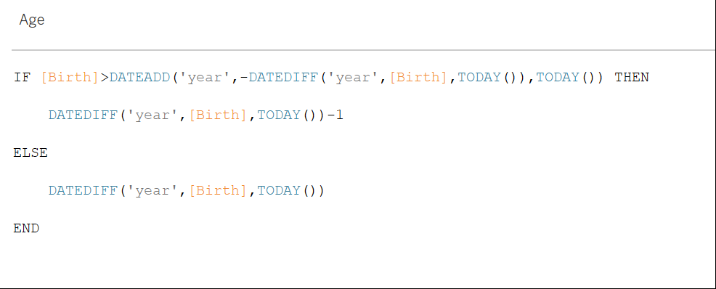

2.**AGE_GROUPS** - Grouped the different age into multiple buckets

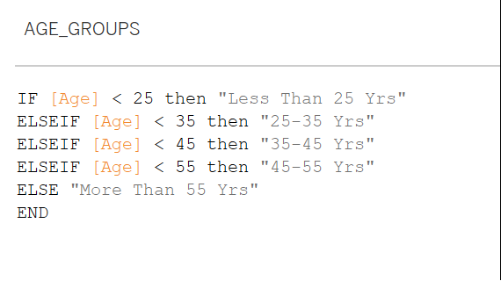

3. **CAR_AGE** – Grouped the different ages of car in to multiple buckets

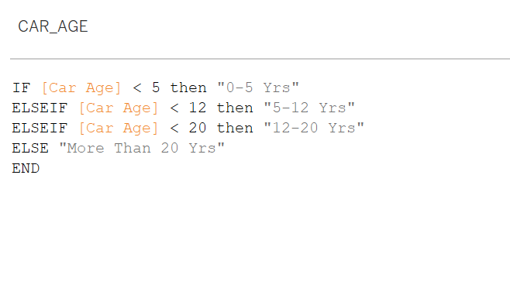

4. **CAR_PRICE** - This is used to group the Car price in to multiple buckets

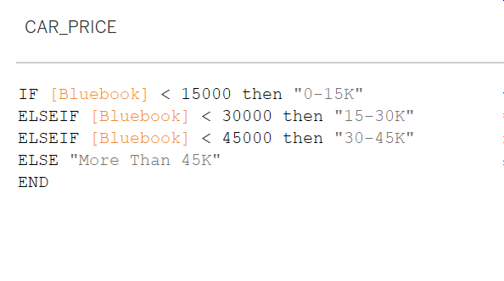

5. **Claim_Freq** - This is used to convert the numerical frequency in to strings

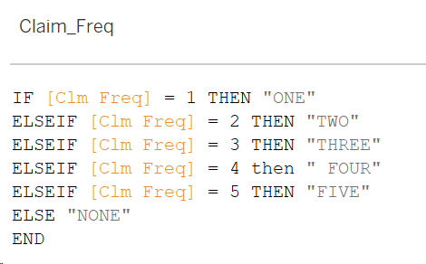

6. **INCOME_GROUPS** - This is created to bucket Income

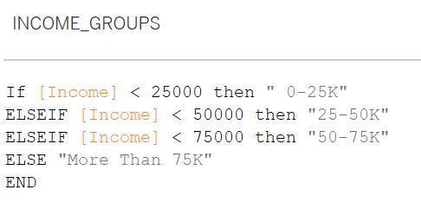

7. **Waterfall** - This is created to create Waterfall chart

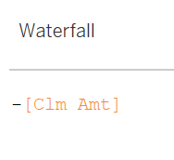

8. **Pearson Correlation Coefficient** - This is created to create Correlation Matrix

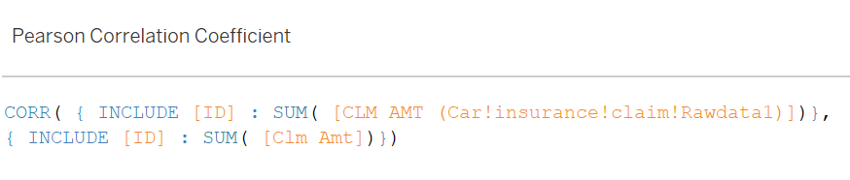

# **Story – Claims by Car Type, Car Use and Different Age Groups**

This dashboard includes 2 different charts.

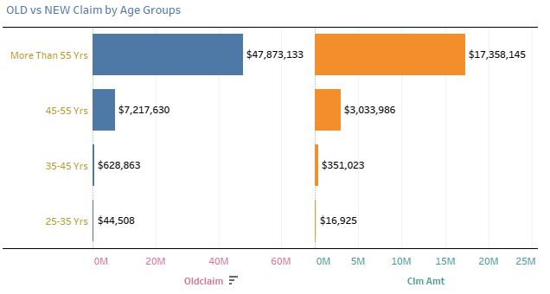

Above chart shows that OLD and NEW claims made by different age groups. Customers who are more than 55years have made high amount of claims i.e. $47,873,133 and $17,358,145 respectively. In contrast customers who are in age group of 25-35Years have made very less amount of claims i.e. $44,508 & $16,925 respectively.

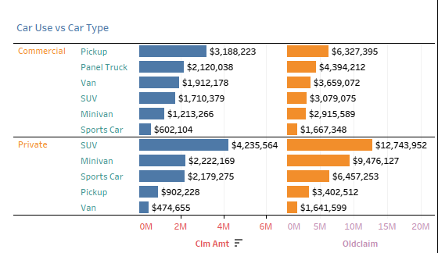

This chart shows the claims made by car type and usage of car. Cars which are used for Commercial purpose had highest claim under “Pickup” Car Type i.e. $3,188,223 & $6,327,395 in contrast with private purpose where SUV is leading i.e. $4,235,564 & $ 12,743,952. At the same time SUV has made medium range of claims under Commercial purpose.

# **Story – Claims by Occupation & Income Groups:**

This story includes 2 charts, which are

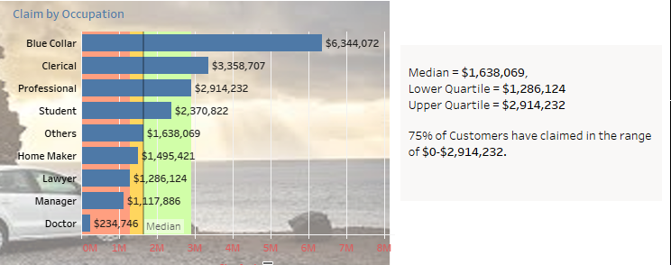

This chart explains claims made based on Occupation. 75% of claims range from $0 to $2,914,232. Median value shows that 50% of claims fall with in the range of $0 to $1,638,069. Also, shows the claims breakup in to 4 quartiles based on occupation

This chart shows the claims by income groups.

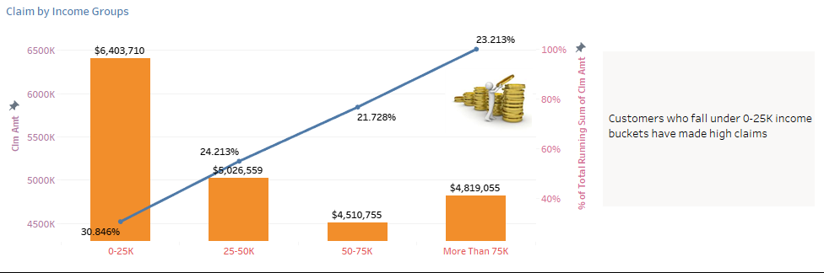

Chart clearly states that customers who fall under 0-25K income groups have made high amount claims which contributes to 30.846% of total claims.

# **Story – Different claim factors of Customers:**

This story has 1 interactive chart, which explains about different factors of customers which are used for claims i.e. Income, Bluebook, Date of Birth, Car Value, Car type and Occupation.

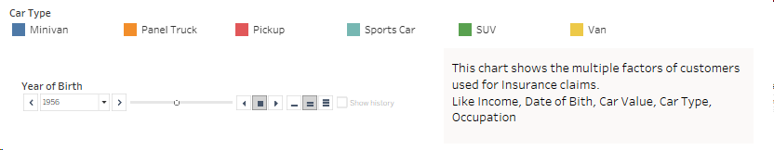

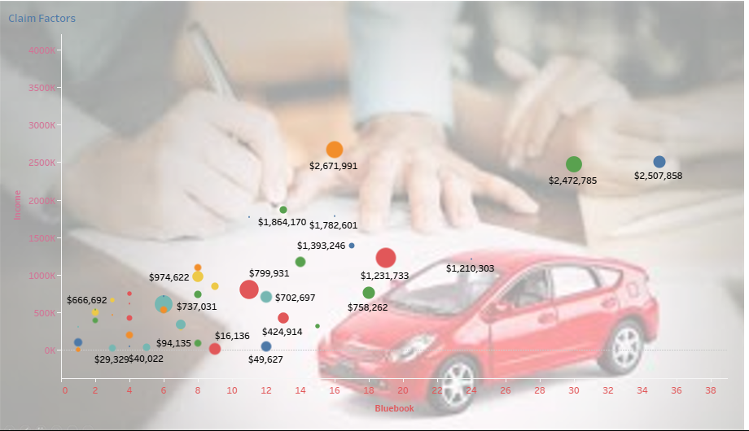

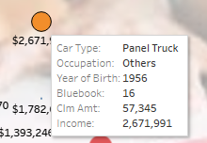

# **Story – Percentage of Claims by Car Type & Correlation Matric Between Occupation:**

This contains 2 charts,



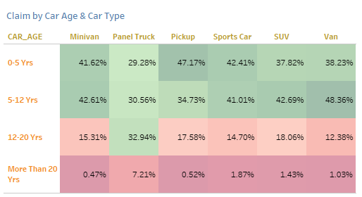

This chart shows that heatmap of claims in the form of percentage based on Car Age & Car Type. It shows that 48% of claims made by cars which fall under 5-12 Years which majorly Vans. The next is Pickup car type which has made claim of 47% which fall under 0-5 Years category.

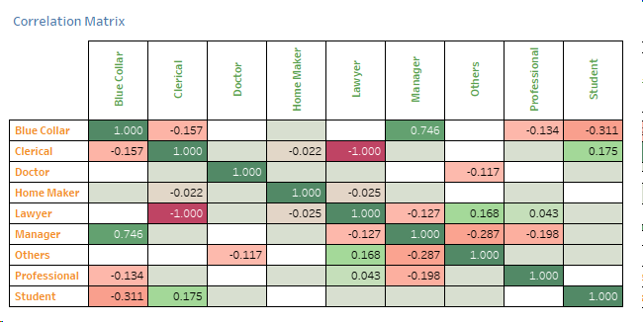

This chart shows the correlation between occupation. Darker the Green color indicates the occupations which are highly correlated. Blue collar & manager Jobs are highly correlated here.

# **Story – Claims by Gender, Marital Status and Claim Frequency**

This has 1 chart,

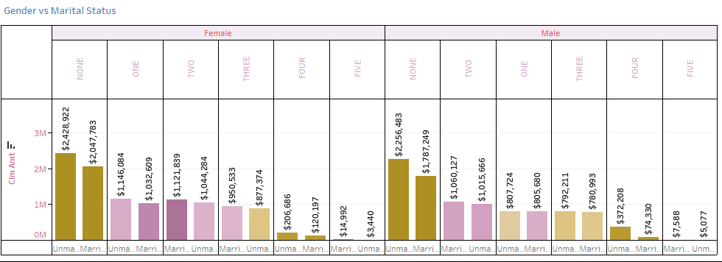

This chart shows the total claims made by Gender, marital status under different claim frequency. It shows that, Females & Males who are married made claims twice for higher amount in comparison with customers who made claims >2 times.

# **Story –Education, Income, Home Value details of customers and cumulative claim by customer occupation:**

This chart shows the tree map of customer Education, Income & Home value. This shows that customers who have finished bachelor’s more successful and are earning high and own a house value of $600M

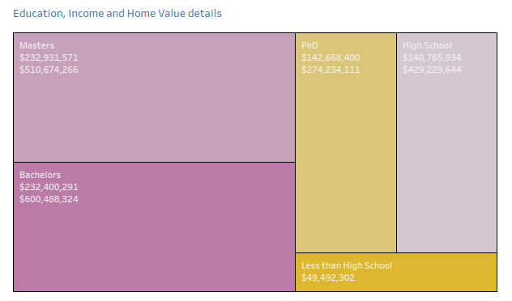

The below waterfall chart shows cumulative and individual claim made by occupation.



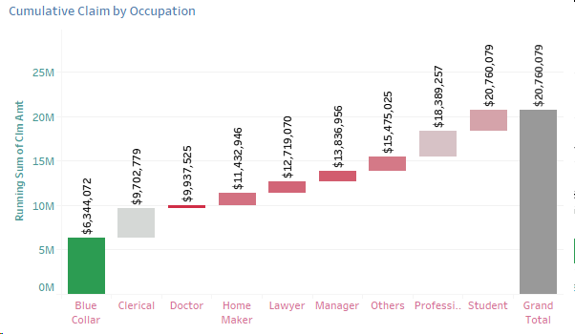

# **Conclusion:**

* Customers who are more than 55years have made high amount of claims i.e. $47,873,133 and $17,358,145 respectively. In contrast to customers who are in age group of 25-35Years have made very less amount of claims i.e. $44,508 & $16,925 respectively.
* Cars which are used for Commercial purpose had highest claim under “Pickup” Car Type i.e. $3,188,223 & $6,327,395 in contrast with private purpose where SUV is leading i.e. $4,235,564 & $ 12,743,952. At the same time SUV has made medium range of claims under Commercial purpose.
* 75% of claims are in the range of $0 to $2,914,232.
* It shows that 48% of claims made by cars which fall under 5-12 Years which are majorly Vans.
* Customers who finished their bachelor’s are more successful.

# **Dashboard Link:**

<https://public.tableau.com/profile/anto.thomson.george#!/vizhome/CarInsuranceClaimsAnalysis/CarInsuranceClaimInsights?publish=yes>

